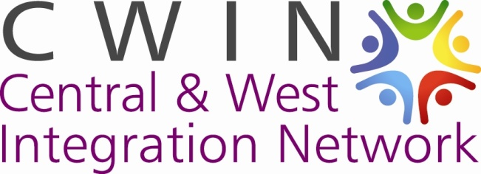

Central and West Integration Network
Development Worker

Introduction

Glasgow’s Integration Networks were developed from 2001 onwards in response to the significant increase in asylum seekers and refugees coming to the city. Initially the networks delivered activities with a focus on supporting the integration of asylum seekers and refugees. Over the years, the networks have become local hubs which bring together local voluntary and public sector organisations to plan and coordinate integration and community work. However, the needs of asylum seekers and refugees remain pressing ones.

Central and West Integration Network (CWIN) was established in 2009 and aims to work with individuals, community groups, voluntary and statutory agencies to support the needs of refugee, migrant and minority ethnic communities and promote cross-cultural understanding, equality and social inclusion.

CWIN offer services to asylum seekers, refugees, BME and local communities. Included in the services provided by CWIN are; food bank, ESOL classes, community events, support for destitute asylum seekers, a youth project and women’s group.

We provide a weekly Food Bank service to at least 60 people, almost all asylum seekers or refugees. We seek to use this as a way of offering other opportunities to the people involved to help them to deal with and overcome the difficulties they face and promote integration into Scottish society. For this purpose, CWIN obtained funding from the Scottish Government Fair Food Fund in order to develop and deliver a Fairer Food Project aimed at organising a weekly drop-in service, building on the existing Food Bank and including:
- Provide Healthy meals
- English Classes
- Weekly information stalls by other service providers and other weekly activities
- Monthly presentations by service providers.
For this purpose, CWIN is looking to fill a vacancy for Development Worker who will develop and run the drop-in service.

In response to the current crisis we have suspended our community meal. Our foodbank has still been running. In the first few weeks after lockdown we focussed our work initially on the safety of the volunteers and our community members. We revised our operations allowing for adequate social distancing by spreading out the preparation time of our food parcels over two days and working with much reduced numbers of volunteers. We have shifted the majority of our food parcels from collection to deliveries in order to help people stay at home. We look forward to welcoming these new members to our community meal once it restarts. Majority of our community engagement work now happen online. We are also planning to begin some outdoor activities for our community members.

CWIN is looking for an enthusiastic individual to cover for the adoption leave of the current post holder. The post is for the period of 9 months.

CWIN Job Description & Person Specification
Development Worker

Location: Garnethill Multicultural Centre, 21 Rose Street
Accountable to: CWIN Development Manager
Contract: The post is for an adoption leave cover, for the period of 9 months
Salary: £23,590 per annum, pro rata 17.5hours
Hours: Days to be agreed and to include Friday
Objective: To deliver CWIN Food Empowerment Project

Job Description
The central role of the Development Worker is to deliver CWIN Food Empowerment Project, with the support of other CWIN staff and volunteers.

The key tasks of the Development Worker are to:
1. Recruit a project Steering Group and involve members in planning
2. Plan and organise drop in service activities
3. Recruit and manage volunteers, involve volunteers in food preparation, serving, setting up the sessions and other project activities.
4. Plan and organise events around drop-in service and support the delivery of CWIN events and activities
5. Monitoring and evaluation of the project.
6. Liaise with partners to ensure effective delivery and further development of project
7. Support service users, signposting them to other sources of support when required
8. Update CWIN website and social media with details on the project.
9. Represent CWIN at Glasgow Food Bank Forum and Glasgow Asylum and Destitution Network, Dignity Project, Independent Food Network, and report back.
10. Carry out such other tasks as may be required in support of CWIN activities.

Person Specification

Skills and experience required

Essential
- Experience of working with community groups and volunteers
- Experience of diverse communities
- Ability to make positive use of social media
- Ability to adapt services for online provision
- Excellent communication skills
- Ability to work unsupervised
- Ability to record and analyse written and numerical data
- Ability to work in a team.

Desirable
- Experience of working in a multicultural environment
- Community Learning and Development qualifications and experience
- Training and experience in food handling
- Experience in managing volunteers
- Experience of working with partners in voluntary and public sectors to deliver projects.

- Deadline for Applications: Friday 16 October 2020 at 5pm

.

