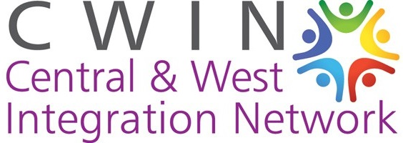
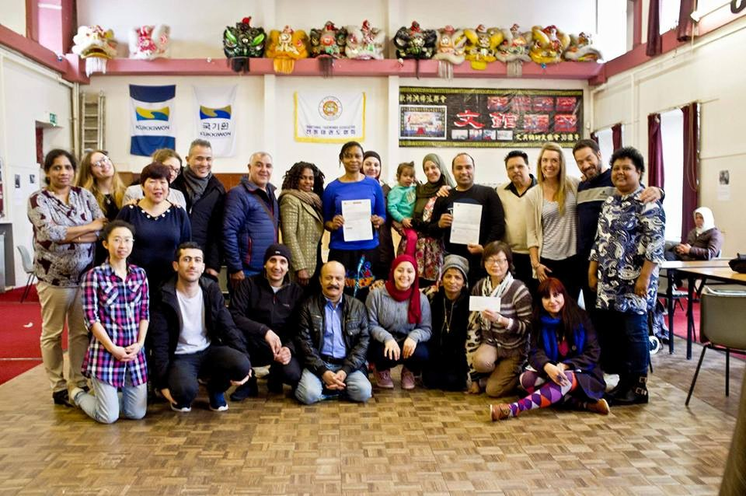
The Central and West Integration Network is a charity which works to support asylum seekers, refugees, black and minority ethnic communities and migrant workers across Glasgow, and actively works to promote integration with these communities.
We offer:
- Weekly drop-in service
- Food bank
- ESOL classes
- RST grant service
- Youth Club
- Women’s Group
- … and more!
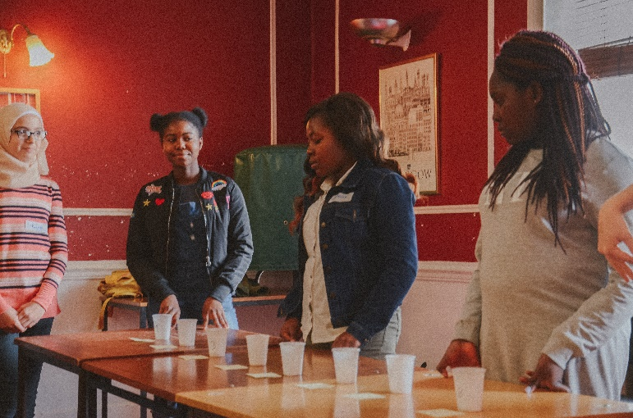
Find us at:
Garnethill Multicultural Centre 21 Rose Street, Glasgow, G3 6RE
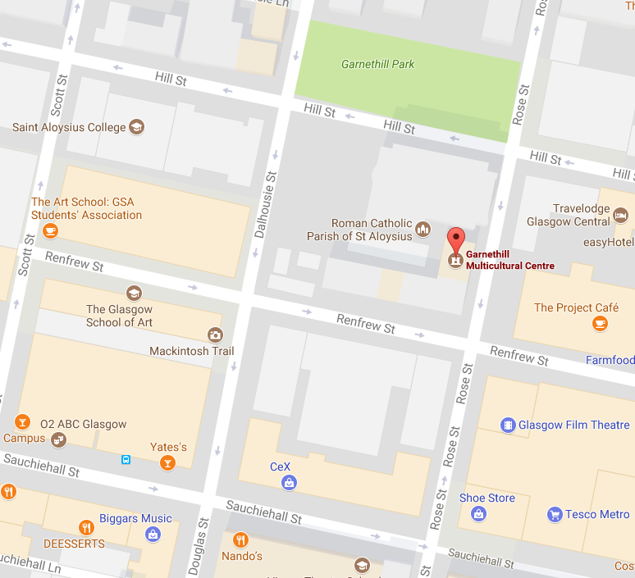
Contact us at:
0141 573 0978 centralandwestintegration@googlemail.com https://www.facebook.com/CWINGlasgowScotlandwww.cwin.org.uk
Services
Activities | When? | Venue
Youth Club (Homework club) | Monday, 3.15-5pm | GMC
Women’s Group (ESOL) | Tuesday, 11-2.45pm | TWC
ESOL classes | Thursday, 12-2pm | GMC
ESOL classes | Friday, 11-12.30pm | GMC
Drop-in service | Friday, 12.30-2pm | GMC
Food bank | Friday, 12.30-2pm | GMC
Youth Club (Cooking class) | Friday, 3.15-5pm | GMC
Youth Club (SHINE workshop) | Friday, 3.30-5.30pm | GMC
ESOL classes | Friday, 3-5pm | TVH
GMC = Garnethill Multicultural Centre, 21 Rose Street, G3 6RE
TVH = Townhead Village Hall, 60 St Mungos Avenue, G14 0PL
TWC = The Whiteinch Centre, 1 Northinch Court, G14 0UG

RST Grant Service
RST Destitution Grant Application Service | Monday, Tuesday, Thursday,  3-5pm | GMC

