Services
Activities | When? | Venue
Youth Club (Homework Fun club) | Monday, 3.15-5pm | GMC
Women’s Group | Tuesday 12-2pm | TVH
Women’s Group | Tuesday, Crafts workshops 1pm to 2.45pm, ESOL 11.30 -1pm | TWC
ESOL classes | Thursday, 12-2pm | GMC
ESOL classes | Friday, 11-12.30pm | GMC
Drop-in service | Friday, 12.30-2pm | GMC
Food bank | Friday, 12.30-2pm | GMC
Youth Club | Friday, 3.15-5pm | GMC
Youth Club (crafts) | Friday, 3.15-5.00pm | GMC
ESOL classes | Friday, 3-5pm | TVH
Citizens Advice Bureau | Wednesday, 1pm to 4pm | GMC
GMC = Garnethill Multicultural Centre, 21 Rose Street, G3 6RE
TVH = Townhead Village Hall, 60 St Mungos Avenue, G4 0PL
TWC = The Whiteinch Centre, 1 Northinch Court, G14 0UG
RST Grant Service
RST Destitution Grant Application Service | Monday, Tuesday, Thursday,  3-5pm | GMC
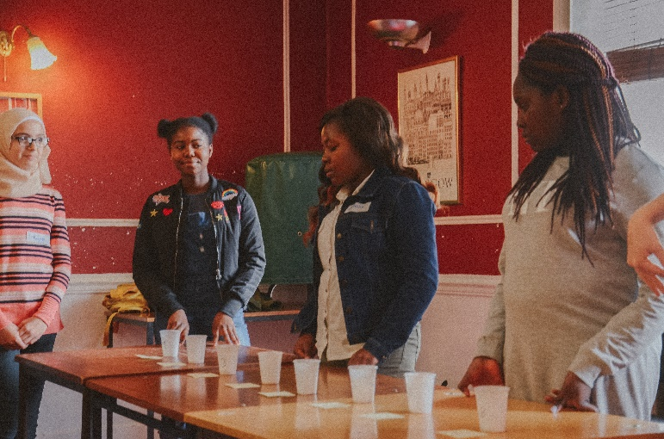
Find us at:
Garnethill Multicultural Centre 21 Rose Street, Glasgow, G3 6RE
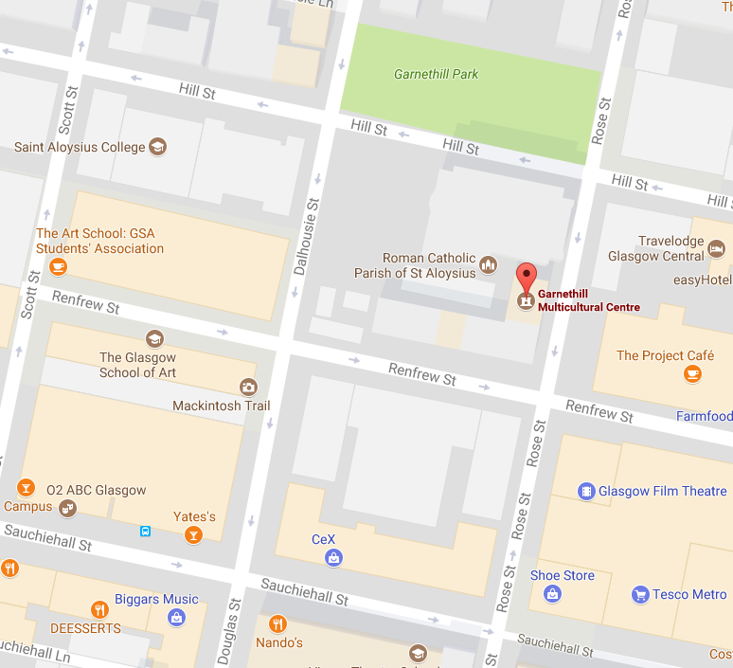
Contact us at: centralandwestintegration@googlemail.com www.cwin.org.uk 0141 573 0978
@CWINGlasgowScotland
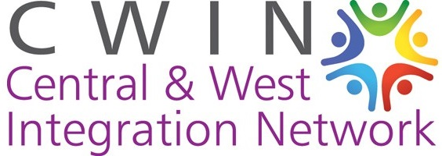
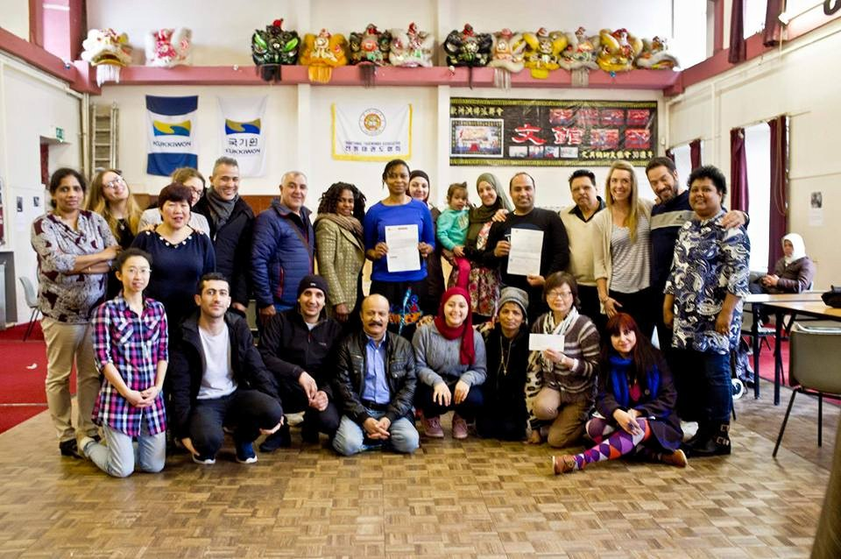
Central and West Integration Network (CWIN) was established in 2009 and aims to work with individuals, community groups, voluntary and statutory agencies to support the needs of refugee, migrant and minority ethnic communities and promote cross-cultural understanding, equality and social inclusion
We offer:
- Weekly drop-in service
- Food bank
- ESOL classes
- RST grant service
- Youth Club
- Women’s Group
- … and more!

ESOL Classes
Tuesdays *Women only*
11.30 -1pm @ The Whiteinch Centre
Thursdays
12-2pm @ Garnethill Multicultural Centre
Fridays
11-12.30pm @ Garnethill Multicultural Centre
Fridays *Women Only*
1-3pm @ Townhead Village Hall

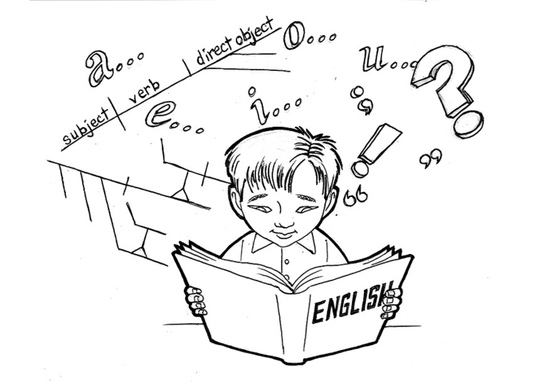

Friday Drop-in Service
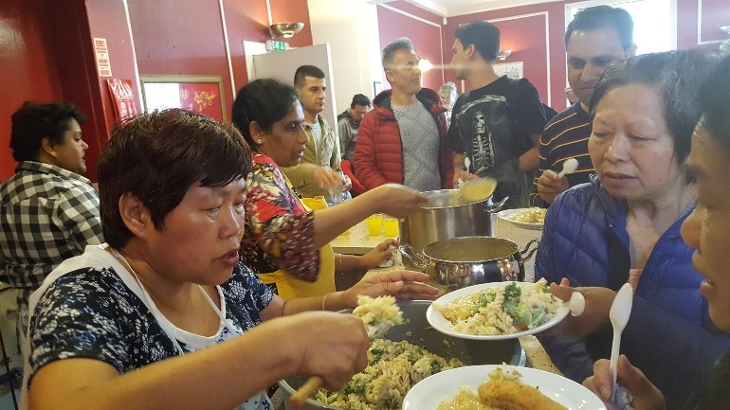
12.30-2pm every Friday
@ Garnethill Multicultural Centre
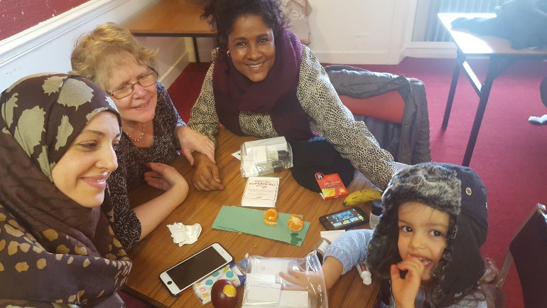
Come to the drop-in for:
- A hot meal
- Information
- Friends
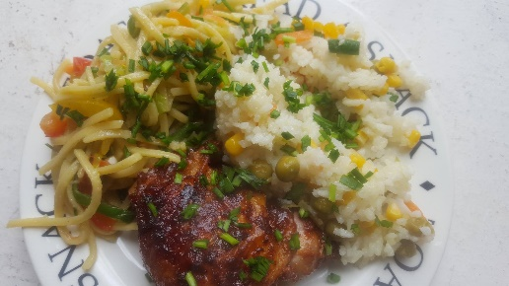
Youth Club
@ Garnethill Multicultural Centre
Monday: Homework Fun Club
3.15-5pm, Ground floor
Friday: Youth Club
3.15-5pm,
Families Crafts Workshops
3.15-4.30pm, Top floor
Families Crafts is for parents and children
