Central and West Integration Network

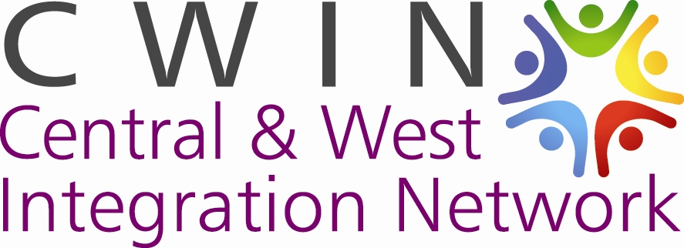

Annual Report 2012/13

Our Background

Central and West Integration Network overall aim is to support communities from BME, asylum seekers and refugees in order to enable them have equal access to services available to the wider population.

To achieve the above we aim to
- Build a network that brings together people and groups from migrant and longer established communities
- Promote integration in order to address practical issues facing migrant communities and achieve equal opportunities
- Work with services to remove barriers to access
- Address discrimination between and within communities
- Build capacity of groups representing or involving migrant communities
- Provide opportunities for cultural and personal exchanges between communities
- Promote health and wellbeing of everyone involved, through promoting positive activity, mutual support and access to information and services

Our Executive Committee Members
Peter Taylor – Chair
Lirie Avdyli – Vice Chair
Ramzan Shah – Treasurer
David Nallatanam – Committee Member
Priscille Mulhearn – Committee Member
Cath McGee – Committee Member
Heidi MacLean – Committee Member

Our Chair’s Report
The social and economic difficulties facing our different communities are not getting any less. Some are extreme, as we can see from the numbers who benefit from our food distribution service. On the other hand there are many positive opportunities available for communities to learn from each other and share activities, such as the forthcoming Glasgow Commonwealth Games.
In 2012/13 Central and West Integration Network had our first full year when we had a stable level of basic funding, even if it was less than in earlier years, and when we were free from the need to concentrate on getting our structure, polices and partnerships properly established. Our funding from Glasgow Community Planning Partnership, received through our partnership for North West Glasgow with the West and Maryhill Integration Networks, has now in fact been confirmed at a steady level for a two year period, and we have been successful in attracting support from a variety of other funders, especially NHS Greater Glasgow.
As a result, we have been able to develop a growing range of activities with our very limited resources. Thanks for this must go to Florence and Julia for all their efforts, and to our volunteers and all our members. In addition to the food distribution and advice services meeting individual need, we have regular activities which bring together people from different communities, such as elderly people in the Stay Well programme and families in our Mother and Child activities. These focus wherever possible on promoting healthy lifestyles and getting people to be active and involved.
We have continued to contribute to cross-city and wider programmes such as GRAND week, Refugee Week, Black History Month and International Women’s Day. Our work to raise awareness of the opportunities arising from the Commonwealth Games led to a memorable event at the Kelvin Hall at which over 100 people learnt about the opportunities, held lively discussions and tried out sports.
Our meetings have provided many opportunities to exchange information and ideas about the issues facing our communities and the actions that people are taking, and which they could take together, to deal with these issues. We continue to offer support to member organisations to develop their own capacity and activities, and hope in future to do a lot more to help them to recruit and support volunteers.
Peter Taylor
Chair
September 2103

Our Treasurer’s Report
I am delighted to give the financial report of Central and West Integration Network and particularly pleased that the organisation has been able to be sustained in the second year running despite the funding climate within the Third Sector. We have been able to maintain our financial stability by securing our core funding and funding from other sources for other activities.

The income and expenditure shows incoming resources for the year as 39,018.27, an opening balance of £16,266 which was carried forward during this financial year.
And total of £47,275.35 expenditure. Staff salaries including payroll administration accounted for £21,157.76 and a total of expenditure with the balance of £26,117.59 being administrative and running costs.

We were successful with funding from Voluntary Action Fund to continue with our work with the Destitute Food Programme. Glasgow City Council continued to fund our core work through the Integrated Grants Fund. We also received grants from Glasgow City Council Anderston/City Area Committee which helped us to continue to develop the Mother and Child Project. Community Food and Health Scotland funded us to do a case study with the Staywell project. Our GRANDWeek event and 16 days of action were funded by Glasgow Community and Safety Services while Scottish Refugee Council supported the Refugee Week event.
 | CWIN
 | Receipt & Payments for the year ended 31 March 2013
Receipts |  | Total £
Voluntary Action Fund |  | 1,000.00
Integrated Grants Fund |  | 30,061.33
Scottish Refugee Council |  | 400.00
Glasgow Community and Safety Services |  | 1,030.00
Glasgow City Council – Anderston City Area Committee |  | 2,296.00
Consumer Focus |  | 3,970.00
Miscelleneous Income |  | 260.94
Total Receipts |  | 39,018.27
Payments
Salaries |  | 27,072.60
Volunteer expenses |  | 747.15
Rent |  | 4,521.30
Insurance |  | 571.70
Stationery |  | 162.32
Travel  Expenses |  | 820.40
Telephone, Broadband & Website |  | 241.50
Postages |  | 19.10
Computer & Mobile Phone |  | 492.99
Board Expenses |  | 113.77
Cleaning supplies |  | 1.60
Professional fees |  | 600.00
Training, workshops & Seminars |  | 600.00
Event expenses |  | 15,630.46
Project Expenses |  | 1,345.46
Subscriptions |  | 250.00
Total Payments |  | 53,190.35
Surplus/(Deficit) |  | (14,172.08)
Opening Balance as at 01.04.2012 |  | 16,266.00
Closing Balance as at 31.03.2013 |  | 2,093.92

Our Services
Capacity Building : Central and West Integration Network continues to hold monthly capacity building meetings which brings together representatives from member organisations. These meetings help strengthen the groups/organisations we work with and create opportunities for them to share and network. The Network had 10 meetings from April 2012 to March 2013. The capacity building work also involves training and one to one support for management committee members of our members on governance issues and funding.
Weekly e-newsletter: CWIN continues to send out weekly e-newsletter to members. The news updates includes information to members on funding, training, conferences/events/seminars, vacancies and other news that may be of interest. It also includes other members and CWIN activities. During this period, up to 48 news updates were sent to members
Allotment: CWIN continued to develop the allotment project during the period which is supported by volunteers. The highlight for the year was that the volunteers were able to create plant pots using disused tyres into different shapes such as sunflower, snail and peacock
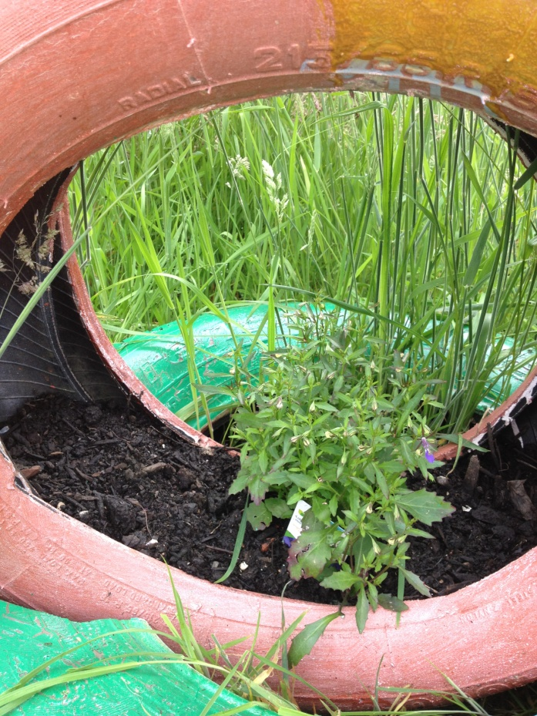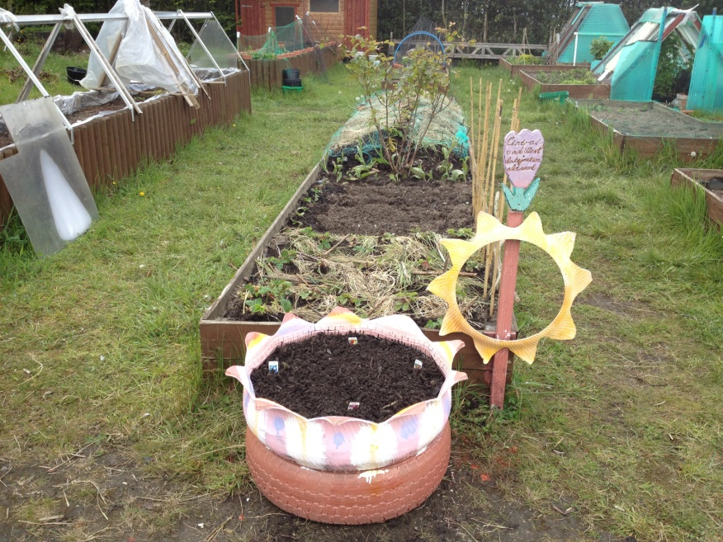

Parents and Child project: This is a new project developed by Central and West Integration Network. It started as a result of the summer 2012 programme. The parents and child group involves children and parents healthy cooking classes, parents zumba classes, children's drama club including drama presentation to parents, children arts and crafts and language classes. Upto 35 adults and 50 children have been supported through this project
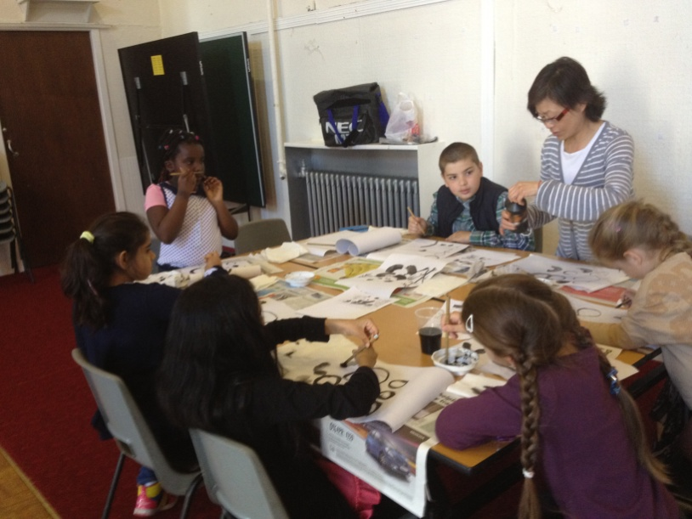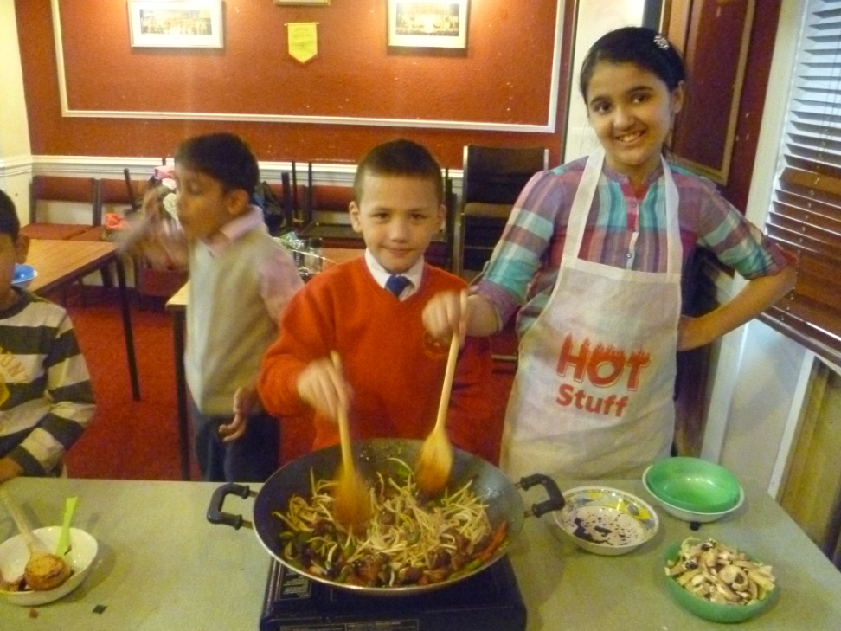
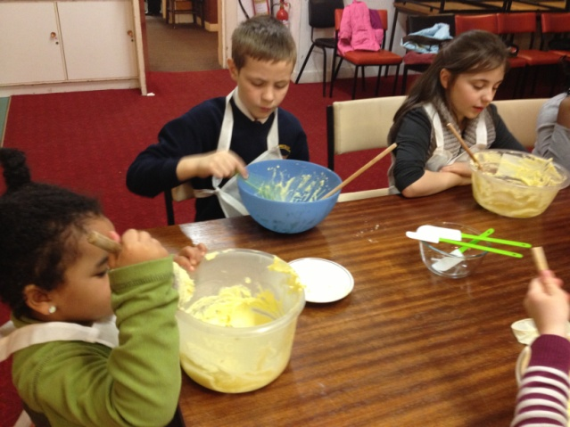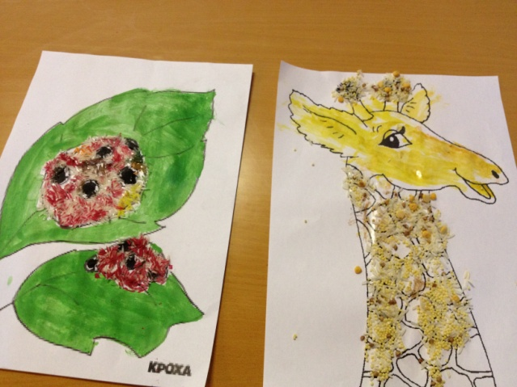
Day outings: The Network supported 5 outings during the period. These include a visit to the Scottish Parliament by BME older and disabled pepole with up to 48 people attending; a visit to Edinburgh Zoo by older Chinese community and their carers with 29 people attending, a group of asylum seekers and refugees and their children visited North Berwick Sea Life Centre with up to 64 people attending. A group of older Indian women were assisted on 2 occasions to go on a barge with up to 10 people attending.
ESOL: In partnership with Glasgow Esol Forum and Garnethill Multicultural Centre, the Network organised an access 2 level English classes

Advice Service: CWIN in partnership with CAB supported a total of 47 individuals on advice and advocay work on issues including welfare benefits, consumer rights, debts, housing, employment, insurance, immigration and fuel.
Stay Well Project: CWIN continued to support older BME population in partnership with 3 elderly day care centres namely Asra, Wah Lok Jung Sam and Shanti Bhavan. The project involved monthly coffee morning/afternoon, arts and crafts activities and food/healthy eating reminiscence work at the various day care centres. Through this work the Network supported 65 older and disabled BME people.
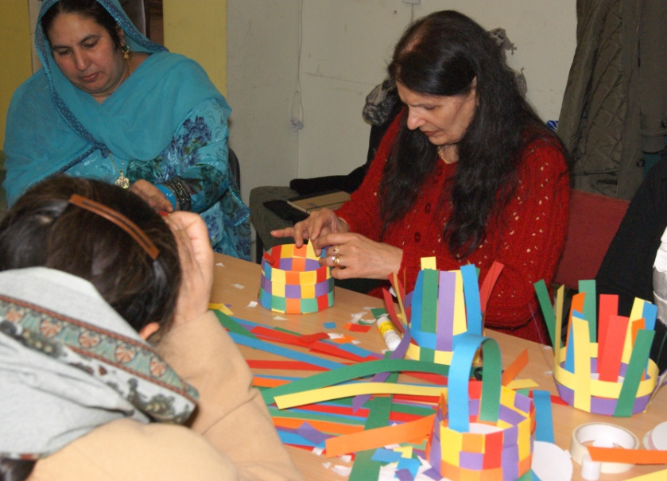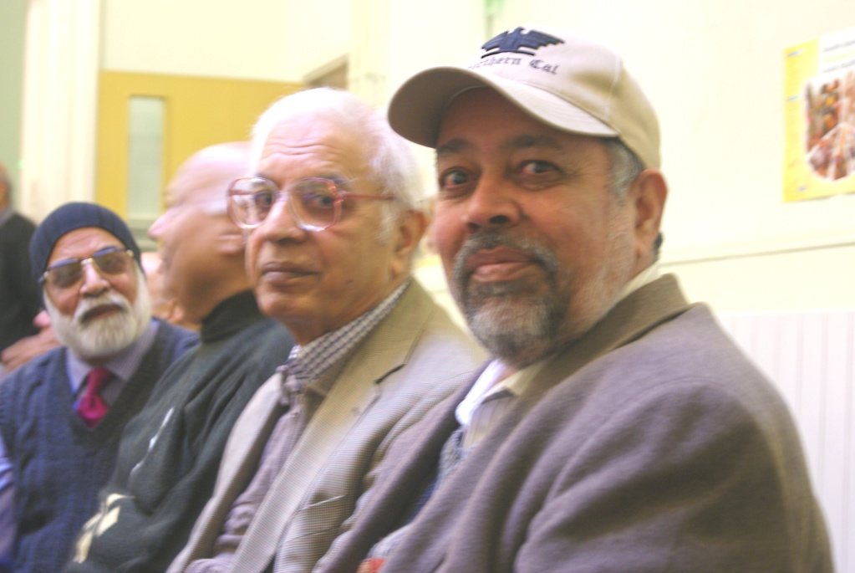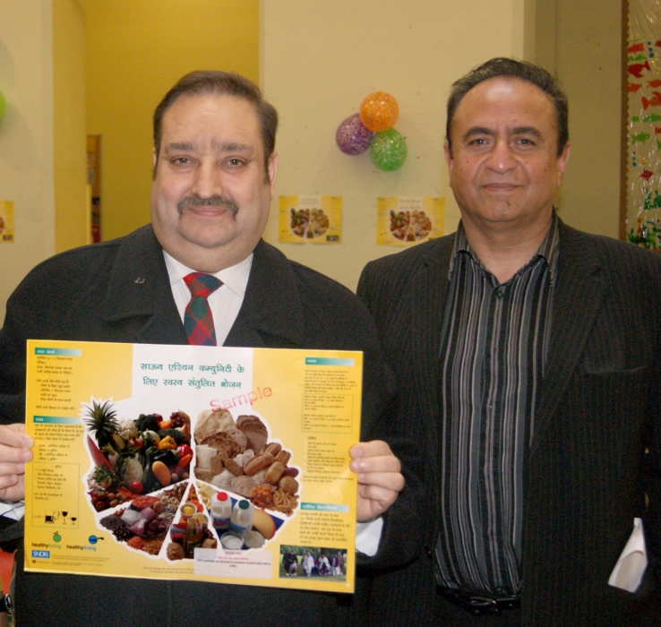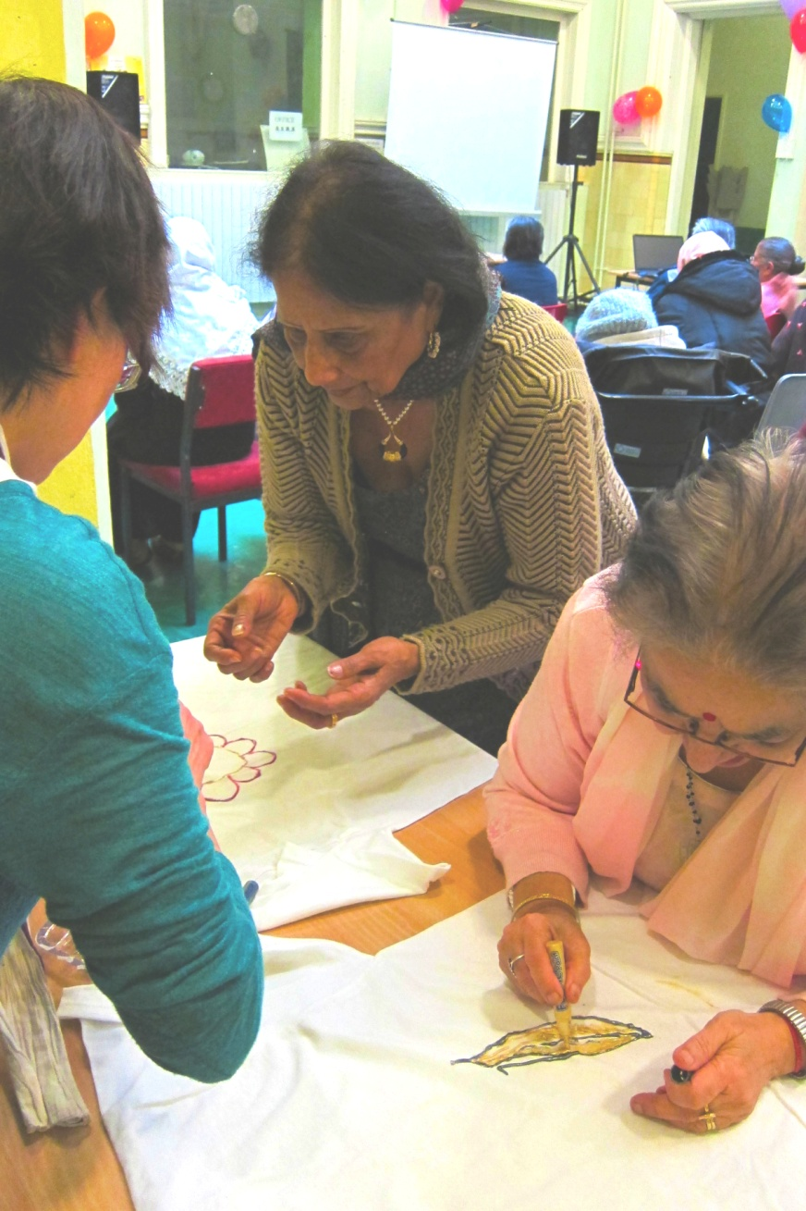
Work with women: Central and West Integration Network supported a number of women's activities during 2012/13. These includes women's exercise clssses, esol classes, cooking classes, arts and crafts classes. In all up to 90 women were supported in the process.

Our Events
CWIN held 12 events so far during 2012/13.
Refugee Week . The event was titled Come, Make and Share - an international crafts event. There was a total of 8 crafts workshops from different parts of the world and up to 60 people attended.
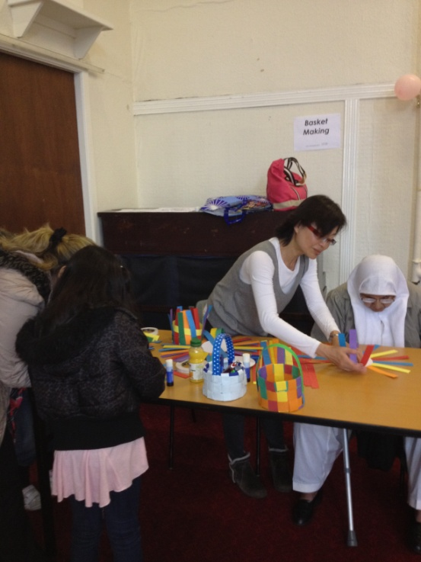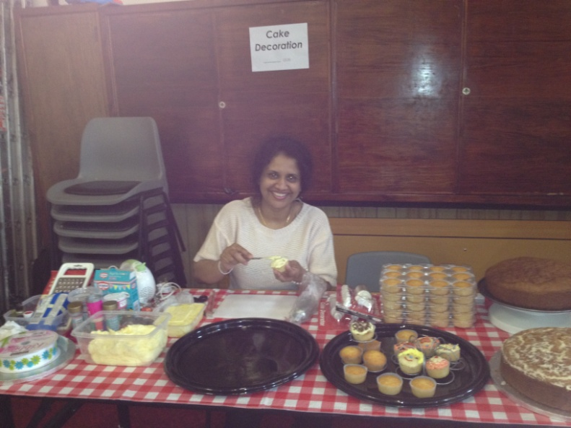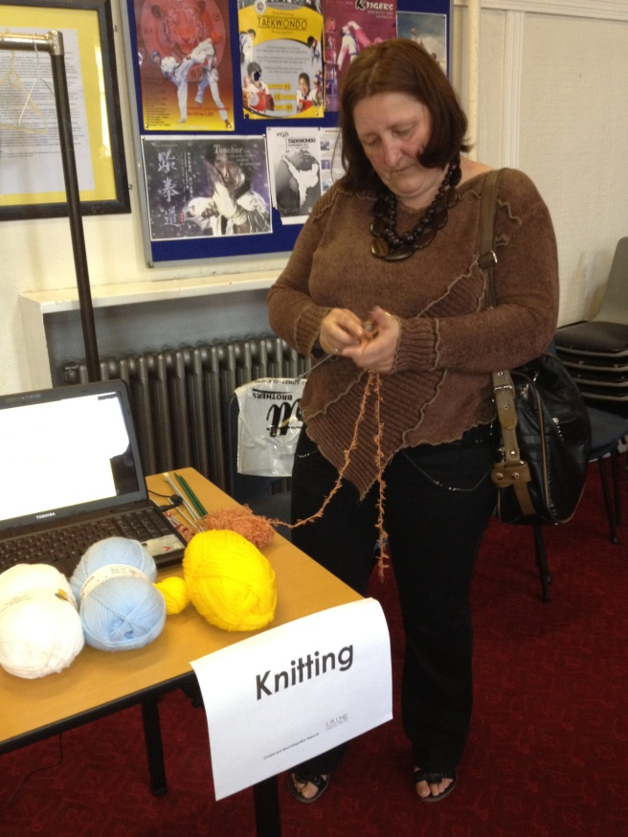

During the GRAND Week 2012 CWIN held an event on 13 September to raise an awareness of drugs and alcohol for BME and local communities 33 people attended the event.
In December 2012 as part of the 16 days of action for the elimination of domestic violence, the network also organised an event where up to 45 people attended.
On 8th March 2013, we held an event to mark the International Women's Day that brought together men, women from BME, asylum seekers and refugees and local communities.
Commonwealth Games Legacy community engagement event in partnership with Scottish Community Development Centre and Glasgow Life at Kelvinhall International Sports Arena. The purpose of the event was to raise an awareness of what is involved in the Commonwealth Games, information on local sports and health activities; opportunity to discuss what a positive legacy might look like for their local communities and to participate in Commonwealth sporting activities on the day. Up to 104 people attended the event. As a result of information received at this event some members of the Network has gone ahead to apply to volunteer for Glagow 2014 Commonwealth Games.
Our Members
We continued to value the support and contribution of our members during this year. Below are the members we worked with in different capavities during the year
Our members
Addaction • African & Caribbean Network • AlbScott (Albanian Scottish Association) • The Annexe Healthy Living Centre• ASRA • Chinese Community Development Partnership • Community Health Partnership North West• Clan Macondo Arts and Languages • Glasgow Chinese Women’s Association • Glasgow ESOL Forum
Glasgow Integrated Community Empowerment • Glasgow Life • Garnethill Multicultural Centre •Glasgow Life• Glasgow Oriental Dance Association • Glasgow West Regeneration Agency • Glasgow Women’s Library • Karen Gordon Photography • La Maison du Congo • North Woodside Community Action Group • Pan African Arts • Peace Arts • Queens Cross Housing Association• Scottish African Women’s Association • Scottish Refugee Council • Strathclyde Police • Strathclyde Fire and Rescue• Volunteer Centre Glasgow • Whiteinch Centre • West Scotland Regional Equality Council • Woodside Youth Initiative • YWCA • Young Fishers Club

Our Funders
We would have been unable to carry out the work we did this year if not for the support of our funders. This year we received funding support from the following
- Glasgow City Council – Integrated Grants Fund
- Glasgow City Council – Anderston/City Area Committee
- Voluntary Action Fund
- Glasgow Community and Safety Services
- Scottish Refugee Council
- Community Food and Health Scotland

